**Canvas Instructions**

**Accessing Student Pairing Code & Creating a Parent Account**

1. On student dashboard click on “Account”

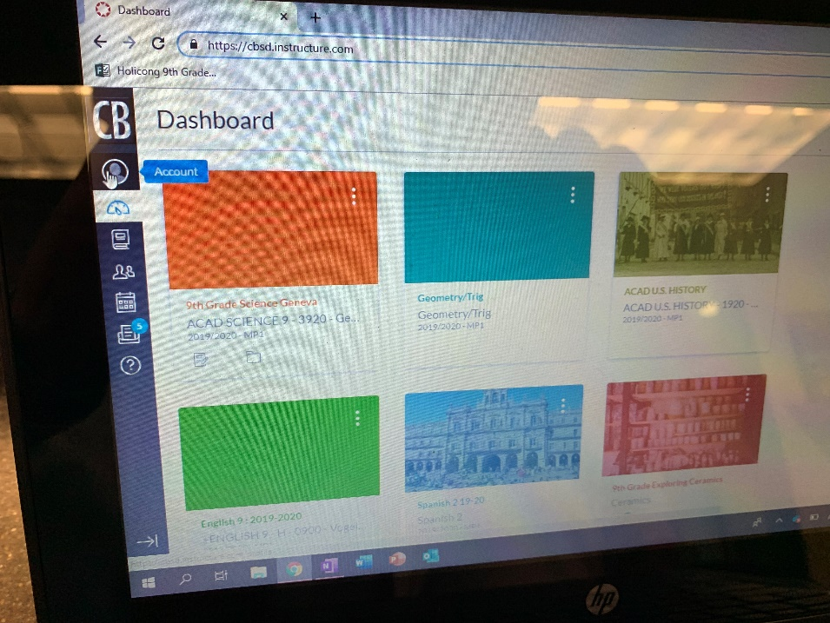

1. Click on settings

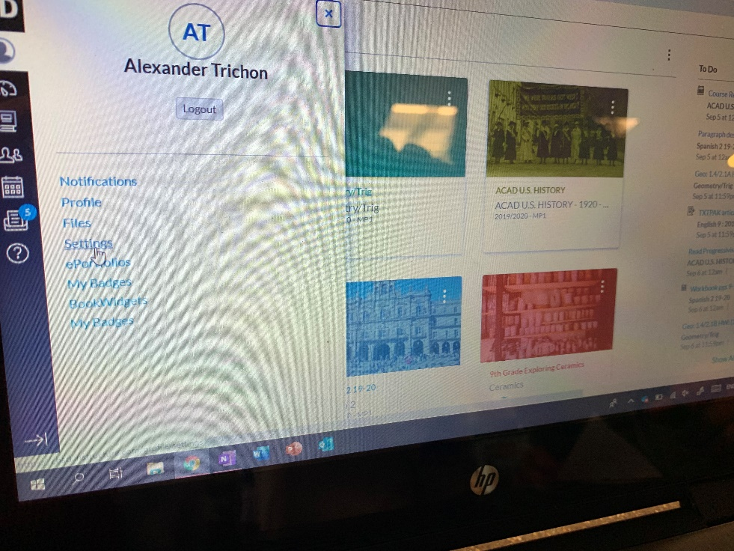

1. Click on “Pair with Observer” (observer = parent/guardian”

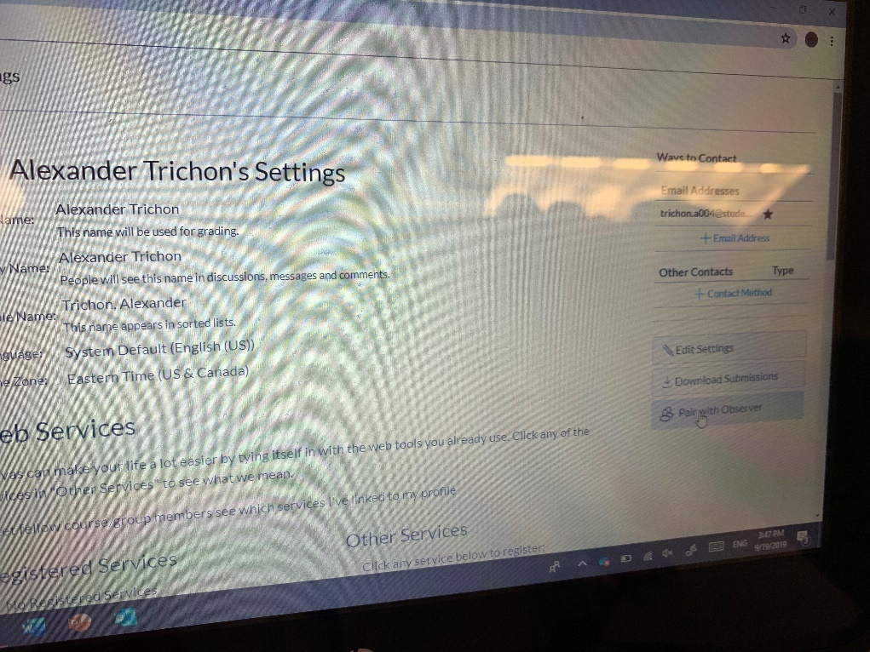

1. When you click on this – a special code will come up specific to your child (we did not include Alex’s here for confidentiality)
2. One parents receive that code you will go to the cbsd canvas page - <https://www.cbsd.org/canvas> and click on Parent Sign In

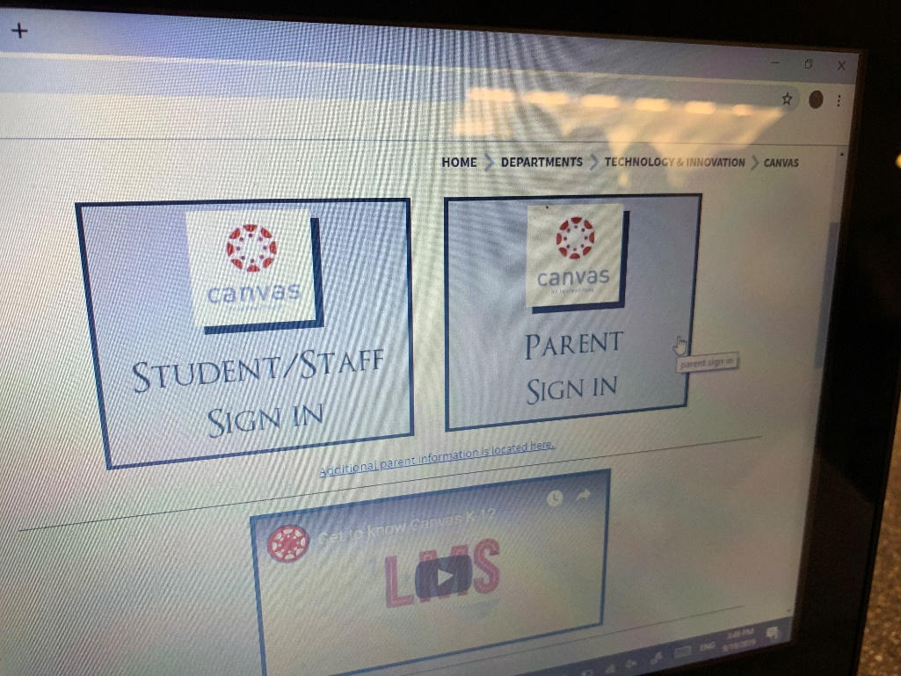

1. Click on “click here for an account”

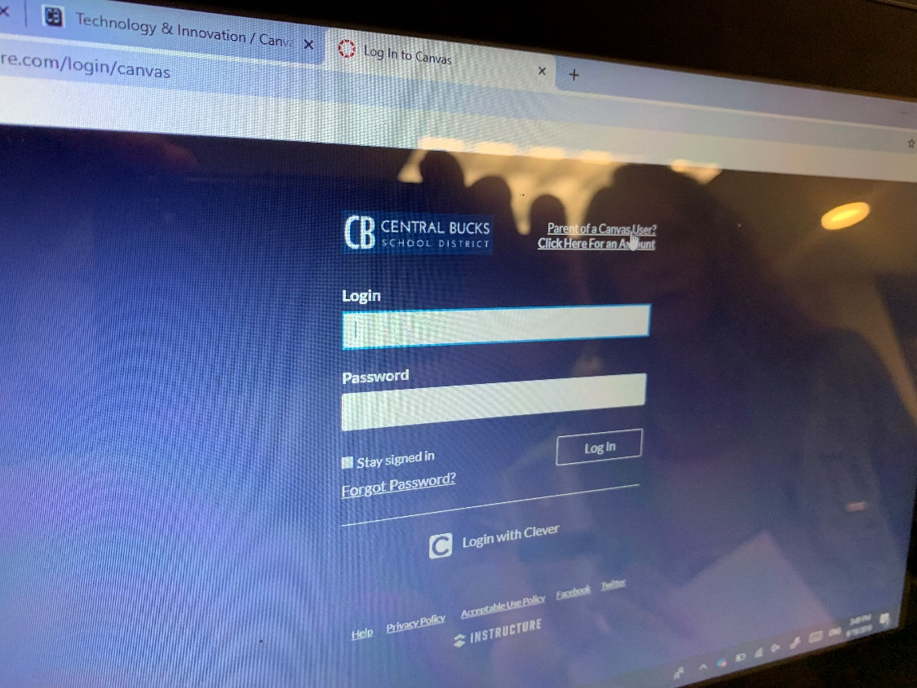

1. Create your login and at the bottom enter the pairing code from above – depending on your browser is will automatically keep you logged in to this account!